🌟 One-line Lock-in (Best Memory Point)
Read slowly:
break belongs to loops and switch.
if only decides when to break,
and labels decide which loop to break.

Step 1: What is a label in Java?
A label is just a name given to something.
Example idea (plain English):
“I am giving a name to this part of code so I can jump to it.”
In Java, syntax looks like:
labelName:

Step 2: What can a label be attached to?

Important rule (simple):
A label can be attached to a statement.
Now the question becomes:
👉 What is a statement in Java?

Step 3: Is a block { } a statement?
Yes ✔️
A block like this:
{
// some code
}
is called a block statement.
So technically (syntactically):
👉 Java allows labels on blocks.
That is why this is VALID syntax:
label: {
break label;
}
No compiler error ❌
So syntactically it is allowed.

Step 4: Then why do we say “this is rarely used and not practical”?
Now comes the real meaning.

Ask yourself:
What does break do?
👉 break is used to exit repetition or selection.
- loops → repetition
- switch → selection

Step 5: What happens if you label a NORMAL block?
label: {
System.out.println("A");
break label;
System.out.println("B");
}
What does this do?
- It prints "A"
- break label; exits the block
- "B" is skipped
That’s all.

Why this is not useful?
Because:
- The block runs only once
- There is no repetition
- There is no selection
- break behaves like a simple jump out
This can already be done using:
- if
- return
- restructuring code
So:
👉 No real problem is solved here

Step 6: Now compare with loops (THIS is the key)

Labeled loop example (thinking only):
outer:
for (...) {
for (...) {
break outer;
}
}
Here:
- Inner loop wants to exit outer loop
- Normal break cannot do that
- Label gives a real solution
👉 This is a real problem
👉 This is why labels exist

Step 7: What about static / instance blocks?
Static block:
static {
}
Instance block:
{
}
They:
- execute only once
- are not loops
- have no repetition
So labeling them gives:
- no real benefit
- no real use-case
Even if syntax allows it, logic does not need it.

Final ultra-clear summary (THIS is THE POINT)

1️⃣ Syntactically
Java allows labels on statements, including blocks.

2️⃣ Practically
Labels are useful only with loops,
because only loops have repetition that needs control.

3️⃣ Therefore
Labeling normal blocks (static, instance, plain {}) is valid but useless.

One-line note (perfect for your notes)
Labels can be written on any statement,
but they are meaningful only with loops;
labeling normal blocks is valid but rarely useful.

✅ Correct Understanding (Clean & Precise)

1️⃣ Unlabeled break;
break; works ONLY inside loops or switch.
So:
- inside if ❌
- inside static block ❌
- inside instance block ❌
✔ UNLESS those blocks are inside a loop or switch.
Example meaning:
if / static / instance block cannot own break
they only carry it for a loop or switch.

2️⃣ Labeled break label;
break label; works even without a loop or switch,
IF the block itself is labeled.
So this is ✔ VALID:
label: {
break label;
}
Because:
- label is attached to the block
- break label; exits that labeled block

🔑 Final Rule Set (Perfect Notes Version)
Unlabeled break; → MUST be inside loop or switch.
Labeled break label; → can exit a labeled block even without loop/switch.
Unlabeled blocks (if, static, instance) need a loop/switch outside.

One-Line Lock-In (Best for Memory)
Only labeled blocks can be broken without loops;
unlabeled blocks need a loop or switch for break to work.

continue — Syntax & Usage Rules (Java)

1️⃣ Syntax of continue

Basic syntax
continue;

Labeled syntax
continue labelName;

2️⃣ Where continue CAN be used ✔️

✅ Inside loops only
- for
- while
- do-while
for (int i = 0; i < 5; i++) {
if (i == 2) {
continue;
}
System.out.println(i);
}
📌 Meaning:
- Skips the current iteration
- Moves to the next iteration of the loop

✅ Inside blocks (if, normal {})
✔ ONLY IF those blocks are inside a loop
while (true) {
if (condition) {
continue; // ✔ valid
}
}
👉 Just like break, if does not own continue
👉 The loop owns it

3️⃣ Where continue CANNOT be used ❌

❌ Outside loops
void test() {
continue; // ❌ compile-time error
}

❌ Inside switch
switch (x) {
case 1:
continue; // ❌ compile-time error
}
Reason:
- continue is meant only for iterations
- switch has no iteration

❌ Inside static / instance blocks (without loop)
static {
continue; // ❌ error
}

4️⃣ Labeled continue

Where labeled continue is allowed ✔️
👉 ONLY with labeled loops
outer:
for (int i = 0; i < 3; i++) {
for (int j = 0; j < 3; j++) {
if (j == 1) {
continue outer;
}
System.out.println(i + "," + j);
}
}
Meaning:
- Skips current iteration of the outer loop
- Goes directly to the next iteration of the labeled loop

❌ Labeled continue with blocks (NOT allowed)
label: {
continue label; // ❌ compile-time error
}
Reason:
- continue needs a loop
- Blocks do not repeat
📌 This is a key difference from break.

5️⃣ Core Difference: break vs continue (Syntax-wise)
Feature | break | continue
Works in loops | ✔️ | ✔️
Works in switch | ✔️ | ❌
Works in blocks via label | ✔️ | ❌
Labeled version | ✔️ (loop/block) | ✔️ (loop only)

6️⃣ Ultra-Simple Notes Points (Perfect for Exam)
continue works only inside loops.
It skips the current iteration and moves to the next one.
Labeled continue works only with labeled loops.
continue never works with switch or normal blocks.

🌟 One-Line Lock-In
continue is iteration-specific:
no loop → no continue.

return — Syntax & Usage Rules (Java)

1️⃣ Syntax of return

a) In void methods
return;
👉 Ends the method execution
👉 Does NOT return any value

b) In non-void methods
return value;
👉 Ends the method
👉 Sends a value back to the caller
Example forms:
return 10;
return x;
return x + y;

2️⃣ Where return CAN be used ✔️

✅ Inside a method (mandatory)
return MUST be inside a method
void test() {
return;
}

✅ Inside loops (for, while, do-while)
✔ ONLY IF the loop is inside a method
void test() {
for (int i = 0; i < 5; i++) {
if (i == 2) {
return; // ✔ valid
}
}
}
📌 Meaning:
- Exits the entire method
- Loop also stops automatically

✅ Inside blocks (if, else, switch, labeled block)
✔ ONLY IF they are inside a method
void test(int x) {
if (x < 0) {
return; // ✔ valid
}
}
int test(int x) {
switch (x) {
case 1:
return 10; // ✔ valid
}
return 0;
}

3️⃣ Where return CANNOT be used ❌

❌ Outside a method
class Test {
return; // ❌ compile-time error
}

❌ Inside static / instance blocks
static {
return; // ❌ compile-time error
}
{
return; // ❌ compile-time error
}
Reason:
- Static and instance blocks are not methods
- return belongs only to methods

4️⃣ Rules based on method return type

void method
void test() {
return; // ✔ allowed
}
void test() {
return 10; // ❌ error
}

Non-void method
int test() {
return 10; // ✔ allowed
}
int test() {
return; // ❌ error
}

5️⃣ Important Control-Flow Rule
When return executes:
- Method execution stops immediately
- Remaining statements are skipped
- Control jumps back to the calling method

6️⃣ Comparison with break and continue (Syntax-wise)
Statement | Scope
break | loop / switch
continue | loop only
return | entire method

7️⃣ Ultra-Simple Notes Points (Perfect for You)
return must be written inside a method.
It can appear inside loops, if, or switch, but it always exits the method.
return cannot be used in static or instance blocks.

🌟 One-Line Lock-In (Best Memory Point)
No method → no return.
Return always terminates the method.

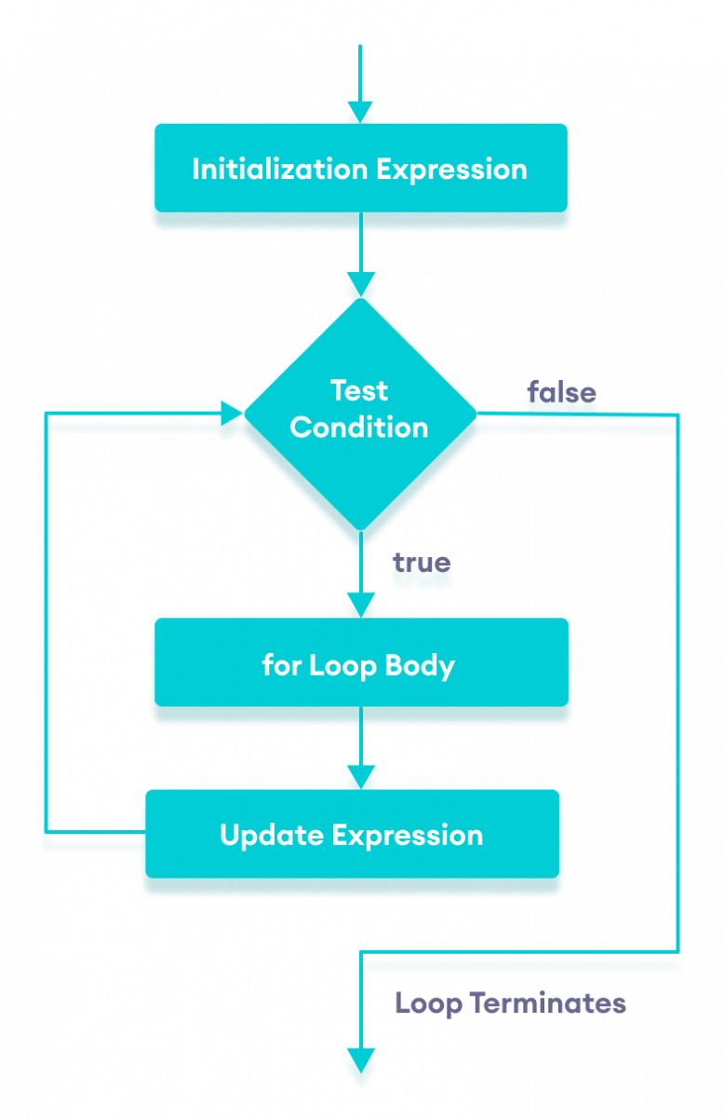

for Loop – Execution Flow (Step by Step)
A for loop always follows the same fixed order.
Think of it as a cycle with checkpoints.

Step 1️⃣ Initialization
👉 Runs only once, at the very beginning.
Purpose:
- Create and set the loop variable
- Decide where to start
Example meaning (in English):
“Start counting from here.”
📌 Important:
- This step never repeats
- It happens only one time

Step 2️⃣ Condition Check
👉 This step decides whether the loop should continue or stop.
What happens:
- Condition is checked
- Result must be true or false
If condition is:
- ✅ true → loop body executes
- ❌ false → loop terminates
📌 Important:
- This step runs before every iteration
- Even before the first execution

Step 3️⃣ Loop Body
👉 This is the actual work you want to repeat.
What happens:
- Code inside the loop executes
- Uses the current value of loop variable
Example meaning:
“Do the task for this iteration.”
📌 Important:
- Body executes only if condition is true

Step 4️⃣ Update Expression
👉 This step changes the loop variable.
Purpose:
- Move towards loop termination
- Avoid infinite loop
Examples (in English):
- Increase counter
- Decrease counter
- Modify value
📌 Important:
- Update happens after body execution
- Then control goes back to condition check

🔁 Cycle Continues
After update:
- Control goes back to Step 2 (Condition Check)
If condition:
- ✅ true → Step 3 → Step 4 → Step 2 …
- ❌ false → loop ends

Loop Termination
👉 When condition becomes false:
- Loop stops completely
- Control moves to the next statement after the loop

🔑 One-Line Flow (Easy to Remember)
Read slowly:
Initialization → Condition → Body → Update → Condition → Body → … → Condition false → Loop ends

🔒 Very Important Observations
- Initialization → once
- Condition → before every iteration
- Body → only when condition is true
- Update → after every body execution
- Condition false → loop terminates

